**User Interface Design**

**MVC Architecture**

* 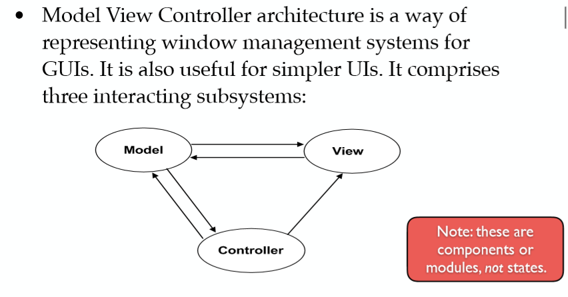Describes the state of the program (FSM)
* 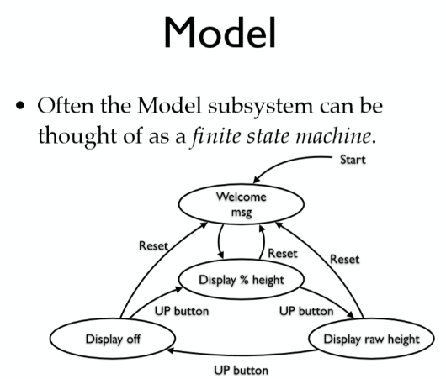MVC = Model View Controller Architecture

View = information stored in the model subsystem to a graphical display

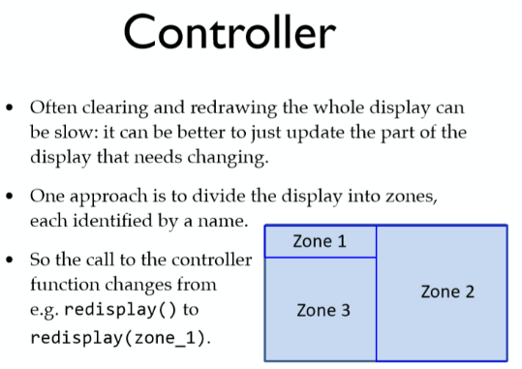Model = data conversion/gathering

View = display

Controller = buttons

**Aspects of GUI Design**

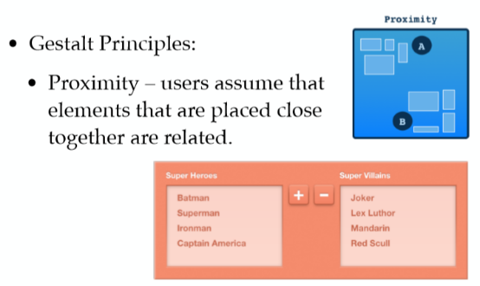**Layout**

* 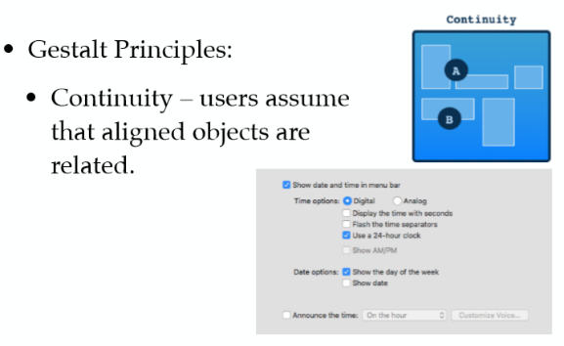not sure what orange is doing – not specified
* 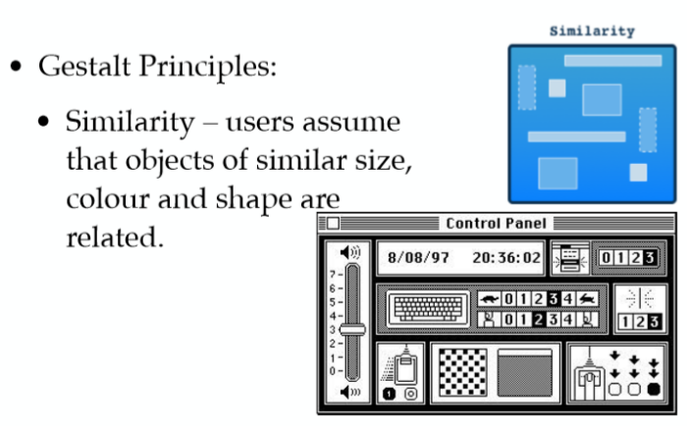Align elements
* Similarity – assume they do the same thing

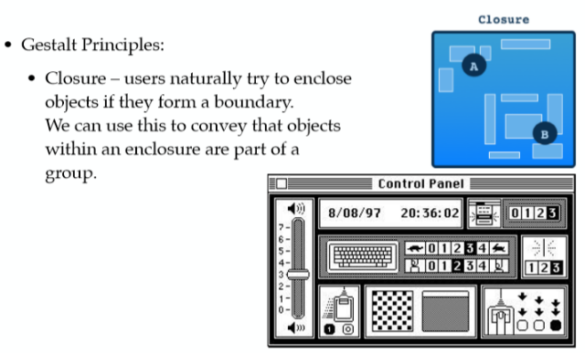

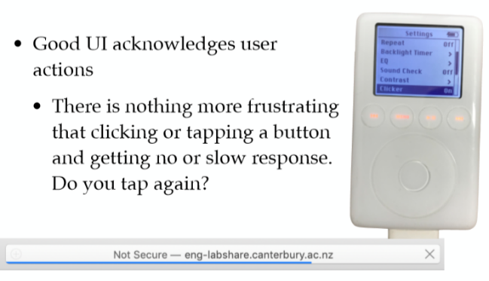**Navigation**

-sequential steps

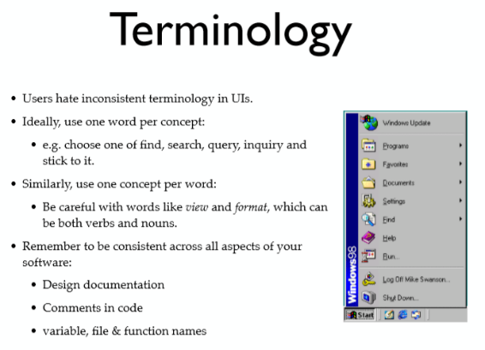- response = clicking action (want to know something has happened)

* Short precise sentences/words e.g describing objects/stuff

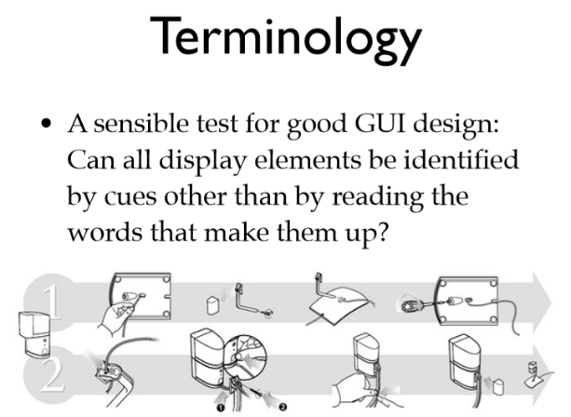

* Don’t necessarily need instructions to be in words (universally understandable)

